**Homework Chapter 2**

Review Questions:

1. A, C
2. C
3. B, C
4. B
5. C
6. B, D
7. A
8. D
9. C
10. B
11. A
12. C
13. D
14. A, B, C, E
15. B
16. A, B
17. C
18. A
19. D
20. B, D
21. B
22. C
23. C
24. B
25. B

Case Projects:

2-1: I will changed the Hubs for Switches and I will get the benefit of Full Duplex from the switches

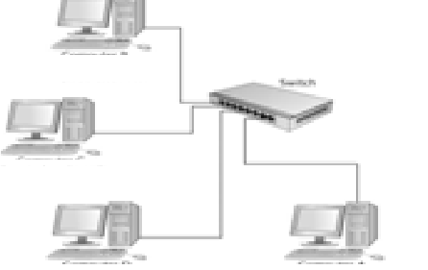 Something like this but with more switches and computers.

2-2: First I will purchase and install routers, second I will split the big LAN into four small LANs, putting each server and the PCs that depend on that server together in a small LAN, and finally I will connect the four LANs with a router.

2-3:

Physical versus logical topology: A logical topology is how devices appear connected to the user. A physical topology is how they are actually interconnected with wires and cables.

Bus topology: One of the three principal topologies for a LAN, in which all nodes are connected to a central cable along which data is passed.

Star topology: A communications network in which all terminals are connected to a central computer, controller or hub.

Ring topology: A communications network that connects terminals and computers in a continuous loop

Ethernet and CSMA/CD: Standard Ethernet networks use CSMA/CD to physically monitor the traffic on the line at participating stations. If no transmission is taking place at the time, the particular station can transmit. If two stations attempt to transmit simultaneously, this causes a collision, which is detected by all participating stations, after a random time interval, the stations that collided attempt to transmit again.